**Docker Lab**

Hello World

Executing a busybox container on our system to use the docker run command.

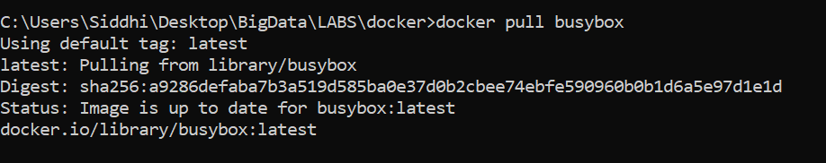

View list of images on the docker container

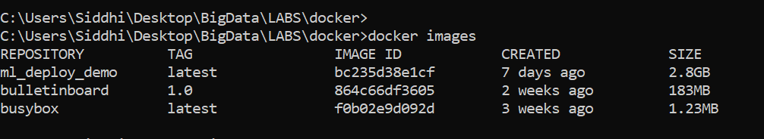

Run Docker



Docker executes echo command in our busybox container and then goes in exited



Cleaning up containers using docker rm command

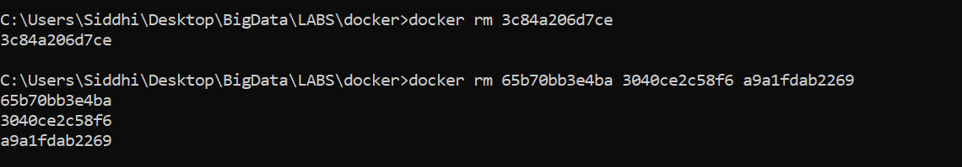

After cloning and extracting from GitHub

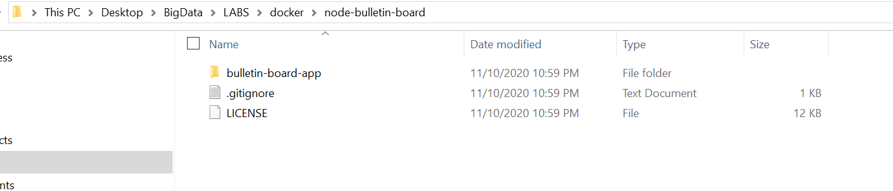

Docker file in the downloaded application

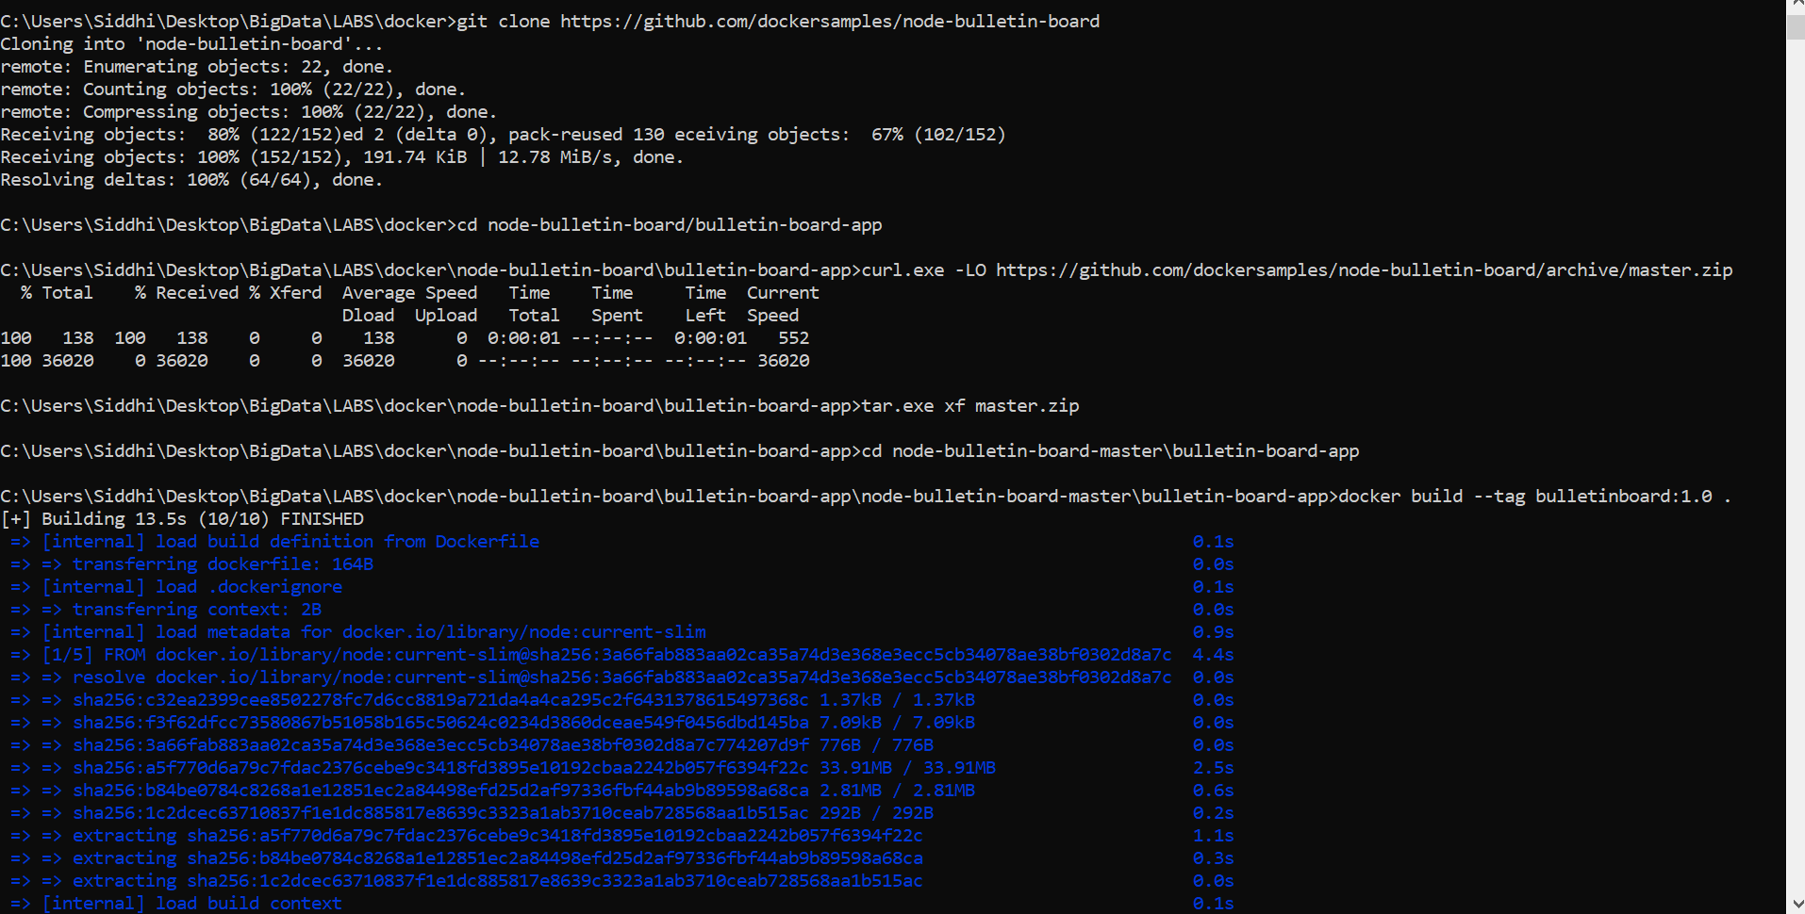

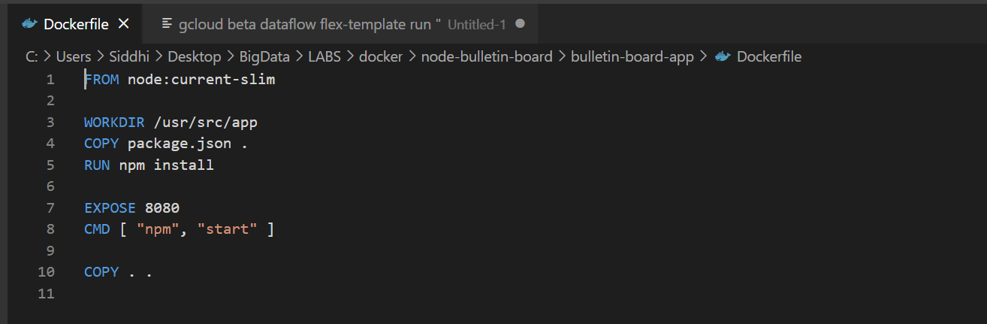

Build and test your image

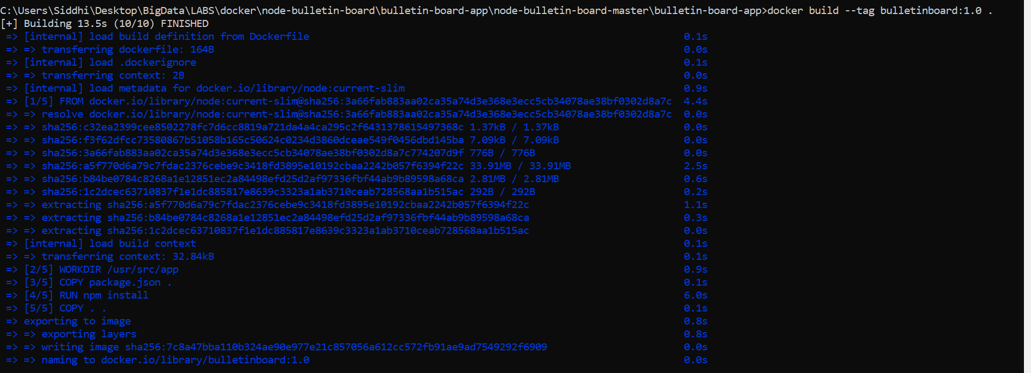

Run your image as a container



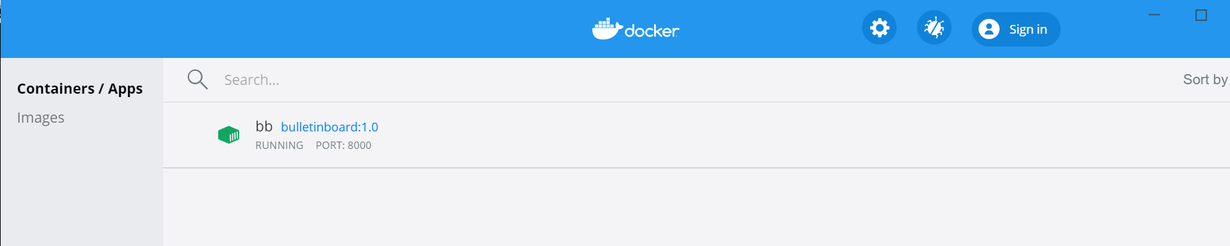

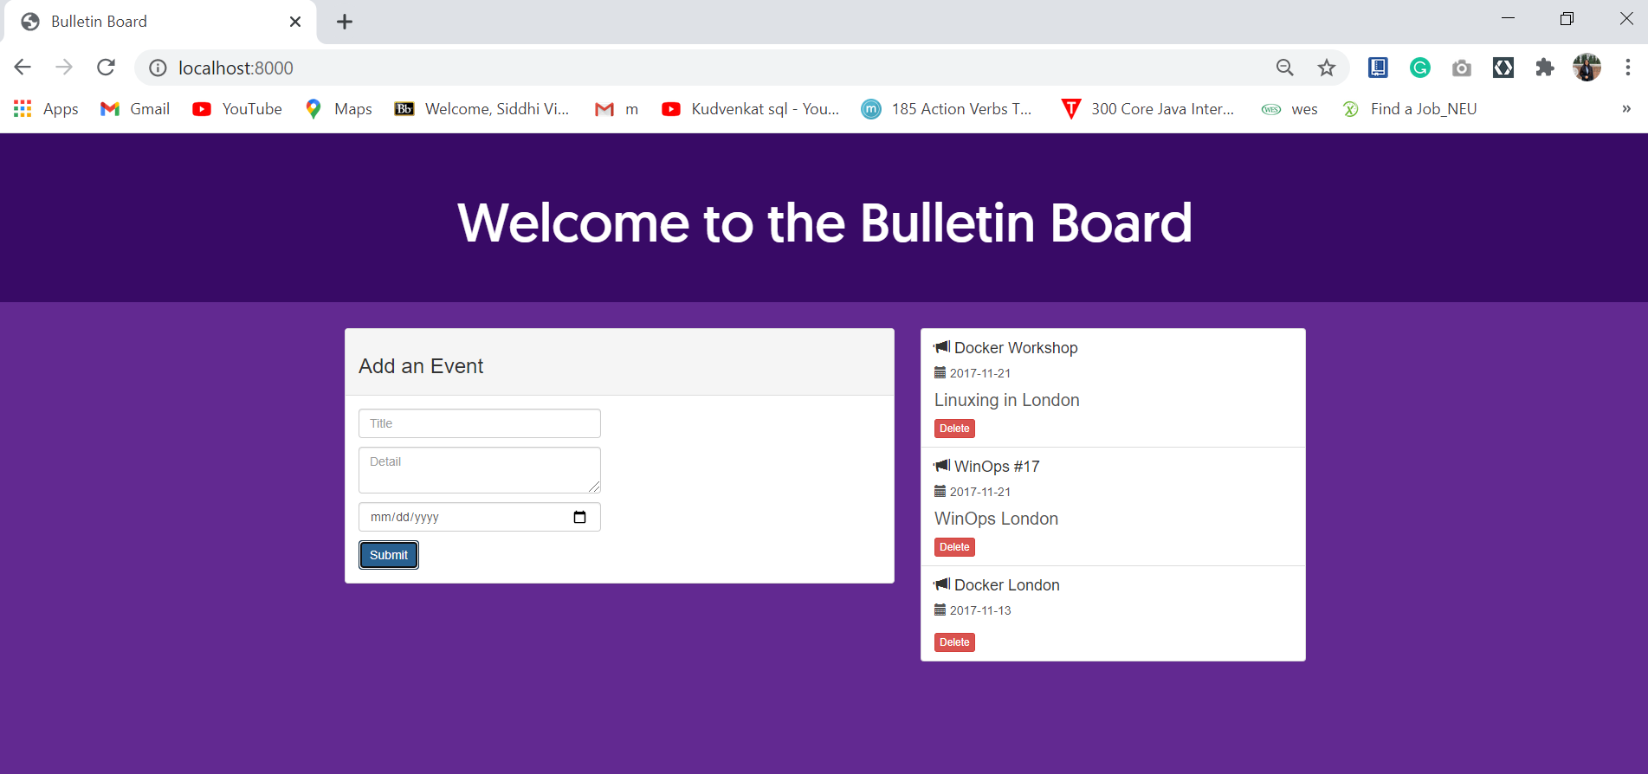

Later we deleted the container



